**1. Write a Servlet application for fetching the entire data from the database and showing it as tablein response webpage.Use the following query in MySQL for creating a table which contains employee details.create table employee(empid varchar(10), empname varchar(20), age integer, salary integer);**

* **Connection Interface** package com.jdbc.demo.connection; //4 Connection interface public interface dBDetails { String ***CONSTR*** =

"jdbc:mysql://localhost:3306/cdac_tvm?useSSL=false";

String ***DBDDRIVER*** = "com.mysql.cj.jdbc.Driver"; String ***USERNAME*** = "root";

String ***PASSWORD*** = "Devesh@123";

}

------------------------------------------------------

* **Connection** package com.jdbc.demo.connection; // 5 connection implementation import java.sql.Connection; import java.sql.DriverManager; import java.sql.SQLException;

public class DbConnection { public static Connection getDbConnection() {

try {

Class.forName(dBDetails.DBDDRIVER);

Connection con=

DriverManager.getConnection(dBDetails.CONSTR,dBDetails.US

ERNAME,dBDetails.PASSWORD); return con;

}

catch(ClassNotFoundException |SQLException exc) { exc.printStackTrace(); return null;

}

}

}

• **EMPLOYEE POJO CLASS** package com.jdbc.demo.pojo; //1 Employee class public class Employee { private int id; private String ename; private int age; private int salary; public Employee() {

}

public int getId() { return id;

}

public void setId(int id) { this.id = id;

}

public String getEname() { return ename;

}

public void setEname(String ename) { this.ename = ename;

}

public int getAge() { return age;

}

public void setAge(int age) { this.age = age;

}

public int getSalary() { return salary;

}

public void setSalary(int salary) { this.salary = salary;

}

*@Override*

public String toString() { return "Employee [id=" + id + ", ename=" + ename + ",

age=" + age + ", salary=" + salary + "]";

}

}

* **Employee DAO CLASS** package com.jdbc.demo.dao; //2 interface Employeedao import java.util.List; import com.jdbc.demo.pojo.Employee;

public interface Employeedao {

//query Operations

List<Employee> getAllEmployee();

Employee searchEmployee(int EmpId);

//curd

boolean addNewEmployee(Employee Empmloyee); boolean updateEmployee(Employee Employee); boolean deleteEmployee(Employee EmpId);

}

* IMPLEMENTATION OF EMPLOYEE DAO CLASSS package com.jdbc.demo.empImp; import java.sql.Connection; import java.sql.PreparedStatement; import java.sql.ResultSet; import java.sql.SQLException; import java.sql.Statement; import java.util.ArrayList; //3 implement employeedao import java.util.List;

import com.jdbc.demo.connection.DbConnection; import com.jdbc.demo.dao.Employeedao; import com.jdbc.demo.pojo.Employee; public class EmployeeDaoImp implements Employeedao{

@Override

public List<Employee> getAllEmployee() { List<Employee> lst=new ArrayList<>();

try(Connection con=DbConnection.getDbConnection()){

PreparedStatement pst=con.prepareStatement("SELECT *

FROM Employee");

ResultSet rs=pst.executeQuery(); while(rs.next()) {

Employee emp=new Employee(); emp.setId(rs.getInt("eid")); emp.setEname(rs.getString("ename")); emp.setAge(rs.getInt("age"));

emp.setSalary(rs.getInt("salary"));

lst.add(emp); }

return lst;

}

catch(NullPointerException |SQLException exc) { exc.printStackTrace(); return null;

}

}

@Override

public Employee searchEmployee(int EmpId) {

Employee emp=null; try(Connection con=DbConnection.getDbConnection()){

PreparedStatement pst=con.prepareStatement("SELECT *

FROM Employee WHERE eid=?");

//at the place of first ? value of EmpId parameter must be there pst.setInt(1,EmpId);

ResultSet rs=pst.executeQuery();

if(rs.isBeforeFirst()) { rs.next(); emp=new Employee(); emp.setId(rs.getInt("eid")); emp.setEname(rs.getString("ename")); emp.setAge(rs.getInt("age")); emp.setSalary(rs.getInt("salary"));

return emp; } return emp;

} catch(SQLException|NullPointerException exc)

{ exc.printStackTrace(); return null;

}

}

@Override

public boolean addNewEmployee(Employee Employee) { try(Connection con=DbConnection.getDbConnection()){

PreparedStatement pst=con.prepareStatement("INSERT

INTO Employee(ename,age,salary)VALUES (?,?,?)",

Statement.RETURN_GENERATED_KEYS); pst.setString(1,Employee.getEname()); pst.setInt(2,Employee.getAge()); pst.setInt(3, Employee.getSalary()); int count=pst.executeUpdate(); ResultSet rs=pst.getGeneratedKeys(); rs.next();

System.out.println("generated id is"+rs.getInt(1)); if(count>0) { return true;

} else { return false;

}

}

catch(SQLException | NullPointerException exc){ exc.printStackTrace(); return false;

}

}

@Override

public boolean updateEmployee(Employee Employee) { try(Connection con=DbConnection.getDbConnection()){

PreparedStatement

pst=con.prepareStatement("UPDATE Employee SET ename=?,age=?,salary=?"

+ " WHERE eid=?");

pst.setString(1,Employee.getEname()); pst.setInt(2, Employee.getAge()); pst.setInt(3, Employee.getSalary()); pst.setInt(4, Employee.getId()); int count =pst.executeUpdate(); if(count>0) { return true;

} else { return false;

} }

catch(SQLException | NullPointerException exc){ exc.printStackTrace(); return false;

}

}

@Override

public boolean deleteEmployee(Employee EmpId) { // TODO Auto-generated method stub return false;

}

}

• **Main class**

package com.jdbcdemo.main;

import java.util.List; import java.util.Scanner;

import com.jdbc.demo.dao.Employeedao; import com.jdbc.demo.empImp.EmployeeDaoImp; import com.jdbc.demo.pojo.Employee; public class AppMain {

public static void main(String[] args) {

//ADD NEW ROW

EmployeeDaoImp daoImp=new EmployeeDaoImp();

Scanner sc=new Scanner(System.***in***);

System.***out***.println("Enter the name"); String name=sc.next();

System.***out***.println("Enter the age"); int age=sc.nextInt();

System.***out***.println("Enter the Salary"); int salary=sc.nextInt();

Employee emp=new Employee(); emp.setEname(name);

emp.setAge(age); emp.setSalary(salary); if(daoImp.addNewEmployee(emp)) {

System.***out***.println("Employee Save");

} else {

System.***out***.println("Employee Not save");

}

}

}

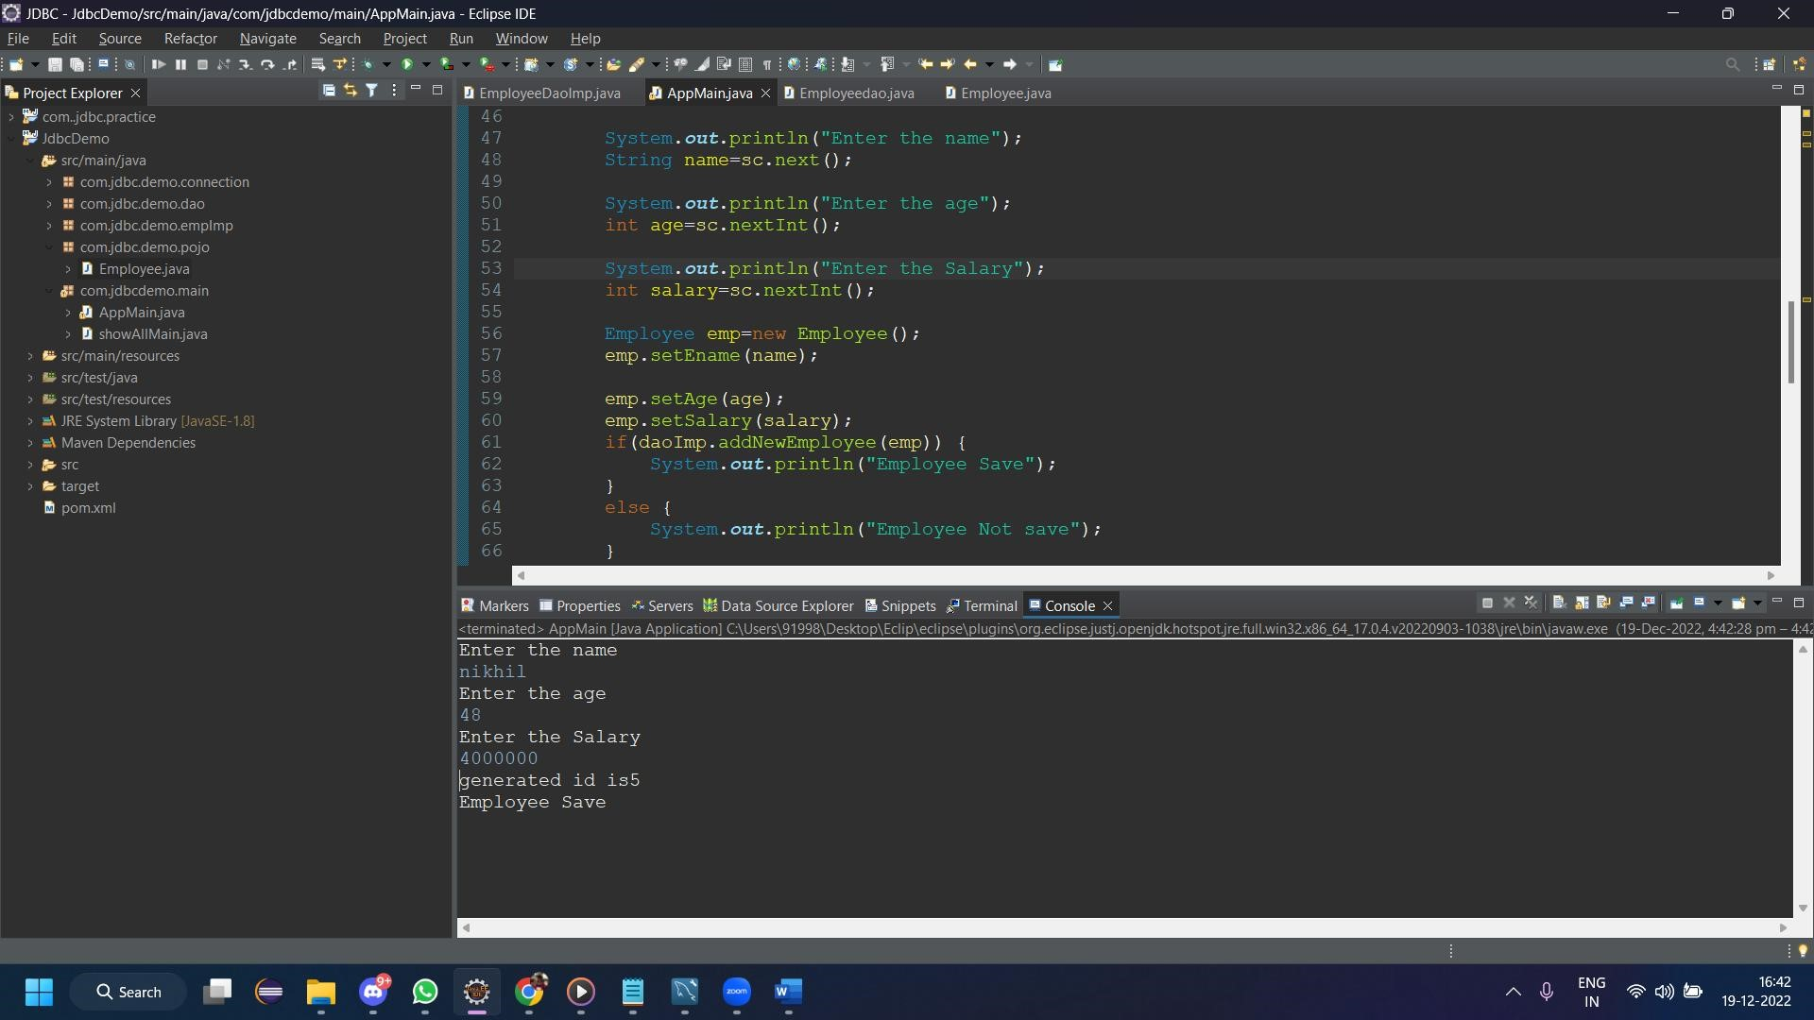

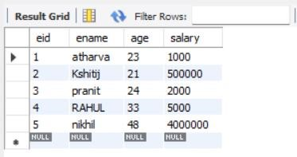

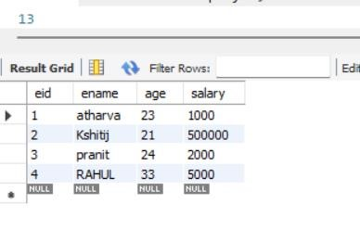

**c)Selecting rows using parameter in the Where clause**

**( select * from emp where age&gt;?)**

* **Connection Interface** package com.jdbc.demo.connection; //4 Connection interface public interface dBDetails { String ***CONSTR*** =

"jdbc:mysql://localhost:3306/cdac_tvm?useSSL=false";

String ***DBDDRIVER*** = "com.mysql.cj.jdbc.Driver";

String ***USERNAME*** = "root";

String ***PASSWORD*** = "patil123";

}

* **Connection** package com.jdbc.demo.connection; // 5 connection implementation import java.sql.Connection; import java.sql.DriverManager; import java.sql.SQLException;

public class DbConnection { public static Connection getDbConnection() {

try {

Class.forName(dBDetails.DBDDRIVER);

Connection con=

DriverManager.getConnection(dBDetails.CONSTR,dBDetails.US

ERNAME,dBDetails.PASSWORD); return con;

}

catch(ClassNotFoundException |SQLException exc) { exc.printStackTrace(); return null;

}

}

}

• **EMPLOYEE POJO CLASS** package com.jdbc.demo.pojo; //1 Employee class public class Employee { private int id; private String ename; private int age; private int salary; public Employee() {

}

public int getId() { return id;

}

public void setId(int id) { this.id = id;

}

public String getEname() { return ename;

}

public void setEname(String ename) { this.ename = ename;

}

public int getAge() { return age;

}

public void setAge(int age) { this.age = age;

}

public int getSalary() { return salary;

}

public void setSalary(int salary) { this.salary = salary;

}

*@Override*

public String toString() { return "Employee [id=" + id + ", ename=" + ename + ",

age=" + age + ", salary=" + salary + "]";

}

}

* **Employee DAO CLASS** package com.jdbc.demo.dao; //2 interface Employeedao import java.util.List; import com.jdbc.demo.pojo.Employee; public interface Employeedao {

//query Operations

List<Employee> getAllEmployee();

Employee searchEmployee(int EmpId);

//curd

boolean addNewEmployee(Employee Empmloyee); boolean updateEmployee(Employee Employee); boolean deleteEmployee(Employee EmpId);

}

* **IMPLEMENTATION OF EMPLOYEE DAO CLASSS** package com.jdbc.demo.empImp; import java.sql.Connection; import java.sql.PreparedStatement; import java.sql.ResultSet; import java.sql.SQLException; import java.sql.Statement; import java.util.ArrayList; //3 implement employeedao import java.util.List;

import com.jdbc.demo.connection.DbConnection; import com.jdbc.demo.dao.Employeedao; import com.jdbc.demo.pojo.Employee; public class EmployeeDaoImp implements Employeedao{

@Override

public List<Employee> getAllEmployee() { List<Employee> lst=new ArrayList<>();

try(Connection con=DbConnection.getDbConnection()){

PreparedStatement pst=con.prepareStatement("SELECT *

FROM Employee");

ResultSet rs=pst.executeQuery();

while(rs.next()) {

Employee emp=new Employee(); emp.setId(rs.getInt("eid")); emp.setEname(rs.getString("ename")); emp.setAge(rs.getInt("age"));

emp.setSalary(rs.getInt("salary"));

lst.add(emp); }

return lst;

}

catch(NullPointerException |SQLException exc) { exc.printStackTrace(); return null;

}

}

@Override

public Employee searchEmployee(int EmpId) {

Employee emp=null; try(Connection con=DbConnection.getDbConnection()){

PreparedStatement pst=con.prepareStatement("SELECT *

FROM Employee WHERE eid=?");

//at the place of first ? value of EmpId parameter must be there pst.setInt(1,EmpId);

ResultSet rs=pst.executeQuery();

if(rs.isBeforeFirst()) { rs.next(); emp=new Employee(); emp.setId(rs.getInt("eid")); emp.setEname(rs.getString("ename")); emp.setAge(rs.getInt("age")); emp.setSalary(rs.getInt("salary"));

return emp; } return emp;

} catch(SQLException|NullPointerException exc)

{ exc.printStackTrace(); return null;

}

}

@Override

public boolean addNewEmployee(Employee Employee) { try(Connection con=DbConnection.getDbConnection()){

PreparedStatement pst=con.prepareStatement("INSERT

INTO Employee(ename,age,salary)VALUES (?,?,?)",

Statement.RETURN_GENERATED_KEYS); pst.setString(1,Employee.getEname()); pst.setInt(2,Employee.getAge()); pst.setInt(3, Employee.getSalary()); int count=pst.executeUpdate(); ResultSet rs=pst.getGeneratedKeys(); rs.next();

System.out.println("generated id is"+rs.getInt(1)); if(count>0) { return true;

} else { return false;

}

}

catch(SQLException | NullPointerException exc){ exc.printStackTrace(); return false;

}

}

@Override

public boolean updateEmployee(Employee Employee) { try(Connection con=DbConnection.getDbConnection()){

PreparedStatement

pst=con.prepareStatement("UPDATE Employee SET ename=?,age=?,salary=?"

+ " WHERE eid=?");

pst.setString(1,Employee.getEname()); pst.setInt(2, Employee.getAge()); pst.setInt(3, Employee.getSalary()); pst.setInt(4, Employee.getId()); int count =pst.executeUpdate(); if(count>0) { return true;

} else { return false;

} }

catch(SQLException | NullPointerException exc){ exc.printStackTrace(); return false;

}

}

@Override

public boolean deleteEmployee(Employee EmpId) {

// TODO Auto-generated method stub

return false; }

*@Override* public List<Employee> PrintSelectStmt(int Age) { List<Employee> lst=new ArrayList<>();

try(Connection con=DbConnection.*getDbConnection*()){

PreparedStatement

pst=con.prepareStatement("SELECT * FROM Employee WHERE age>?"); pst.setInt(1,Age);

ResultSet rs=pst.executeQuery(); while(rs.next()) {

Employee emp=new Employee(); emp.setId(rs.getInt("eid")); emp.setEname(rs.getString("ename")); emp.setAge(rs.getInt("age")); emp.setSalary(rs.getInt("salary")); lst.add(emp);

// lst.add(new Employee(rs.getInt(1),

rs.getString(2), rs.getInt(3),rs.getInt(4)));

} return lst;

}

catch(NullPointerException |SQLException exc) { exc.printStackTrace(); return null;

}

}

• **Main**

package com.jdbcdemo.main;

import java.util.List; import java.util.Scanner; import com.jdbc.demo.dao.Employeedao; import com.jdbc.demo.empImp.EmployeeDaoImp; import com.jdbc.demo.pojo.Employee; public class AppMain { public static void main(String[] args) {

//Select Query For age

Scanner sc=new Scanner(System.***in***);

EmployeeDaoImp daoImp=new EmployeeDaoImp();

System.***out***.println("Enter the age: "); int age=sc.nextInt();

List <Employee>lst=daoImp.PrintSelectStmt(age);

if(lst.size() > 0) {

System.***out***.println("AGE OF employe greater

then : "+age); lst.forEach(System.***out***::println);

} else

System.***out***.println("no employee found");

}

}

**3.Create a stored procedure ‘empproc’ in the database from MySQL command prompt**

**Using the command: create procedure empproc(In eid int , out ename varchar(15)) begin**

**select name into ename from emp where id =eid; end**

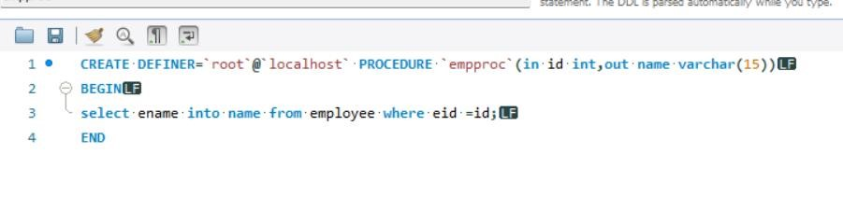

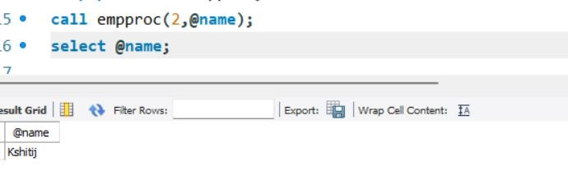

**Write a java application which calls the above procedure** • **Interface of DbConnection**

package com.jdbc.demo.connection; //4 Connection interface public interface dBDetails { String ***CONSTR*** =

"jdbc:mysql://localhost:3306/cdac_tvm?useSSL=false";

String ***DBDDRIVER*** = "com.mysql.cj.jdbc.Driver";

String ***USERNAME*** = "root";

String ***PASSWORD*** = "patil123";

}

//allowPublicKeyRetrieval=true&

• **Implement Employee DbConnection** package com.jdbc.demo.connection; // 5 connection implementation import java.sql.Connection; import java.sql.DriverManager;

import java.sql.SQLException;

public class DbConnection { public static Connection getDbConnection() {

try {

Class.forName(dBDetails.DBDDRIVER);

Connection con=

DriverManager.getConnection(dBDetails.CONSTR,dBDetails.US

ERNAME,dBDetails.PASSWORD); return con;

}

catch(ClassNotFoundException |SQLException exc) { exc.printStackTrace(); return null;

}

}

}

* **Interface class of Employeedao**

package com.jdbc.demo.dao; //2 interface Employeedao import java.util.List; import com.jdbc.demo.pojo.Employee; public interface Employeedao {

String callProcedure(int Empid);

}

* **Implementing of employeedao** package com.jdbc.demo.empImp; import java.sql.CallableStatement; import java.sql.Connection; import java.sql.PreparedStatement; import java.sql.ResultSet; import java.sql.SQLException; import java.sql.Statement; import java.sql.Types; import java.util.ArrayList; //3 implement employeedao

import java.util.List;

import com.jdbc.demo.connection.DbConnection; import com.jdbc.demo.dao.Employeedao; import com.jdbc.demo.pojo.Employee; import

com.mysql.cj.jdbc.CallableStatement.CallableStatementParamInfo; public class EmployeeDaoImp implements Employeedao{

@Override

public String callProcedure(int Empid) { try(Connection con=DbConnection.getDbConnection()){

CallableStatement cs=con.prepareCall("{call

empproc(?,?)}"); cs.setInt(1,Empid);

cs.registerOutParameter(2, Types.CHAR); cs.execute();

String result = cs.getString(2);

return result;

}

catch(NullPointerException|SQLException exc){ exc.printStackTrace(); return null;

}

}

}

• **Main**

package com.jdbcdemo.main;

import java.util.List; import java.util.Scanner;

import com.jdbc.demo.dao.Employeedao; import com.jdbc.demo.empImp.EmployeeDaoImp; import com.jdbc.demo.pojo.Employee; public class AppMain { public static void main(String[] args) //Call procedure

EmployeeDaoImp daoImp=new EmployeeDaoImp();

Scanner sc=new Scanner(System.***in***); System.***out***.println("Enter the eId: "); int id=sc.nextInt();

String name=daoImp.callProcedure(id);

System.***out***.println(name);

}

}

